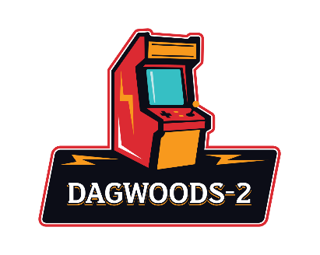
Birthday Party Application
Thank you for considering Dagwoods 2 for your party! Applications are due at least a week in advance to your party date to ensure availability. When you book a party with us, we will block off a section for your party and keep it reserved for 2 hours. After the 2 hours you may stay, but we may have to move you if there is another party following you. You must provide your own cake, plates, napkins and silverware.

Full name & relationship to birthday person:_____________________________
Phone number:_______________________________________________________
Date & time of party:__________________________________________________
How many people attending party:_______________________________________
Please check which package you’d like to purchase:

[ ] Package 1 - $25
- Section Block Off Only
[ ] Package 2 - $125
- Section block off
- Goodie Bags for 10 People
(Each bag includes: Bottle of water, Capri Sun pouch, bag of popcorn, string cheese, granola bar, Rice Krispy Treat, package of Oreos, candy bar.)
[ ] Package 3 - $100 per hour
- Reserve Entire Building
- Pool tables set to free play
Add Ons:
[ ] Birthday Banner hung at no additional cost - (see photos at end of the application to choose banner)
[ ] Extra Goodie Bags - $10 per bag
A Deposit of $25 is due at the time of booking to hold the date and time. Dagwoods does not allow outside food or drink other than cake for the party. Any additional snacks or drinks need to be purchased on site. Dagwoods requires at least one adult (over 18) present for the duration of the party. Please ensure everyone attending abides by all Dagwoods rules posted. Dagwoods is not responsible for any injuries. If any equipment/machines are damaged by party goers, host will be held responsible. We reserve the right to end the party early if we deem it necessary due to excessive rule breaking or safety concerns.

Signature:________________________________ Date:________________



